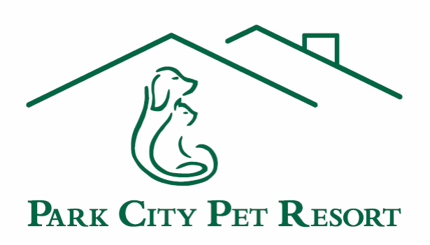

Park City Pet Resort Client Agreement

***PLEASE READ AND INITIAL EACH ITEM***

Initials ____ Park City Pet Resort reserves the right to immediately change your pet’s type of boarding/daycare if we believe it is necessary to protect the health and wellbeing of your pet, other pets, or our staff.

Initials ____ All pets must be healthy and current on all vaccinations. You will be required to bring a copy of your pet’s updated vaccination records from your vet before you start daycare or boarding with us to ensure your pet’s safety as well as that of our other guests.

Initials ____ Pets with flea, lice or tick problems will not be allowed to stay here until cleared by a veterinarian.

Initials ____ Checkout time for boarders is 10:00 AM. Pet’s leaving after this time will be charged a late pick-up fee of $28.50. All charges must be paid in full upon pick-up of your pet.

Initials ____ The brand of pet food we use is Science Diet. If you are feeding your pet any other type of food, we strongly recommend you bring it with you. Changing pet food may cause severe upset stomach and/or diarrhea. We do charge per feeding to use our food ($1/cup)

Initials ____ Owners are welcome to bring their own beds, blankets, or toys if desired; however we cannot guarantee that they will be returned in the same condition or at all.

Initials ____ If pet becomes ill or if the state of the animal’s health otherwise requires professional attention, Park City Pet Resort, in its sole discretion, may engage the services of a local veterinarian or provide appropriate medical attention to the animal and any and all expenses thereof shall be paid by the owner.

Initials ____ Owner is aware that by leaving said pet at Park City Pet Resort, or any other pet facility, said pet is at a higher risk of contracting canine cough, viruses, or acquiring nicks, cuts and possibly punctures. While we have taken special care in designing our facility and maintaining a high standard of cleanliness and safety, no vaccine is 100% guaranteed. If your pet becomes ill with a contagious infection that may have been acquired while boarding, Park City Animal Clinic will provide care for this infection at a 50% discount. The window for care is three-days after boarding admittance and ends three-days after checkout.

Initials ____ I understand that I am solely responsible for any harm or damage caused by my pet(s) to persons or property of the owners, employees and invitees of Park City Pet Resort, or any other pets housed or visiting Park City Pet Resort while my dog(s) is/are attending Park City Pet Resort.

Initials ____ Cancellation within 7 Days of reservation will result in the loss of the deposit. Cancellation within 24 hours of reservation will result in a 50% cost of the entire reservation. Credit Card information is required upon making reservation.

You release, indemnify, and agree to hold Park City Pet Resort harmless from any and all manner of damages, claims, loss, liabilities, costs or expenses, causes of actions or suits, whatsoever in law or equity, (including, without limitation, attorneys’ fees and related costs) arising out of or related to the services provided by Park City Pet Resort. Owner acknowledges and understands that there are certain risks involved in pet ownership, training, and care, including, but not limited to, fights, bites to humans and/or other pets, and the transmission of disease. With Owner’s signature below, he/she understands the risk involved in putting his/her pet in a cage-free environment and acknowledges and accepts exclusive and sole responsibility for all medical expenses to said pet no matter the cause. Owner also authorizes the release of said pet’s medical records from pet’s veterinarian.
By signing this contract and leaving pet with Park City Pet Resort, owner certifies to the accuracy of all information given about the pet. Furthermore, owner has read and understands all procedures and policies included herein.

Signature ____________________________ Date __________________

